ELCT 201 – EE Laboratory 1

Measuring a Transfer Function

Jacob Vaught
9/11/2022

Department of Electrical Engineering
University of South Carolina
Columbia, SC 29208

Abstract
In this lab, a simple RC Circuit was constructed and tested. A sinusoidal signal with an amplitude of 4 V_{p-p} was applied to the circuit. Measurements were taken at many different frequencies, ranging from 10Hz to 100,000 Hz in order to graph the V_{out}/V_{in} transfer function as a function of frequency. A square wave was also applied to the circuit to measure the transient response and determine the time constant of the circuit. The results of the lab should match the expected results from the circuit simulations run in LTSpice. Testing should show that although the angle of phase shift increased as the frequency increased, the time shift between the input and output voltage decreased.

Computer Model(LT-Spice)
A SPICE model was generated for a transient analysis. An alternating sinusoidal voltage source was created with a amplitude of 2 V_{p}. A 10 kΩ resistor was added to the positive terminal of the voltage source, and a 0.01 μF capacitor is added to the ground terminal of the voltage source. The terminals of each of the components are connected to each other, and the ground is attached to the ground terminal of the voltage source.
Figure 1. The Figure above shows the Circuit created in LT-Spice.
A decade AC sweep analysis was run in LT-Spice with 10 Hz and 100kHz as the start and stop frequencies, respectively. 10,000 was chosen as the number of data points for each decade, as it was a good compromise between computational expense and accuracy. The LT-Spice simulation showed that the output voltage starts at approximately 2 V_{p} and ends at 25 mV at 100 kHz. The phase shift is approximately 0 degrees at 10 Hz and increases to 89.08 degrees at 100 kHz. The transient analysis can be seen in Figure 2. An AC analysis was also run with a square wave voltage source with an upper voltage of 2 V, and a lower voltage of -2 V. The pulse wave had a period of 1 ms. View Figure 3 for reference. The output Voltage can be model by Equation 4.

Figure 2. The Figure above showsphase shift and voltage of the output. The dotted line shows the phase shift of the output voltage and the input voltage. The solid line shows the output voltage in dB.

Figure 3.The above figure show the capacitor(output voltage) charging and discharging and the input voltage source(a square wave).

To verify the computer model, a circuit can be set up with a function generator and a Oscilloscope.

Physical MODEL (Verification of computer model)
A physical model was created with the same characteristics as the computer model. The function generator was set to generate a sinusoidal signal with a peak voltage of 2 and no DC offset. Channel 1 of the oscilloscope is connected to the input signal of the circuit, and channel 2 was connected to the output signal of the circuit. Refer to Figure 4 for a simplified Circuit Diagram. The phase shift of the RC circuit at any frequency can be determined by Equation 1, and the time shift can be determined by Equation 2. The RMS voltage of a sinusoidal wave can be determined by Equation 3.
$ϕ=2π*f*R*C$ (Eq 1)
$Time shift={\frac{f}{ϕ}}/{2π}$ (Eq 2)
$V_{rms}=0.707*V_{p}$ (Eq 3)
$V_{out}=V_{in}\left(\frac{1}{\sqrt{1+{\left(2π*f*R*C\right)}^{2}}}\right)$ (Eq 4)
Figure 4. The above figure shows a simplified version of the circuit built in-lab to verify the LT-Spice model.

Figure 5. The above figure shows the model built on a solderless breadboard, connected to all equipment.

Results
The results of the physical model matched the computer-generated results very accurately.
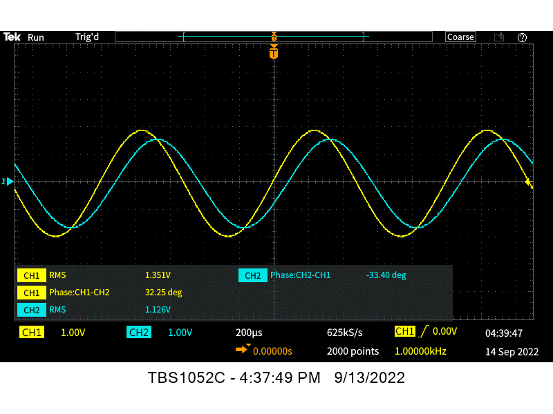
Figure 6. The above figure shows the Oscilliscope reading of the physical model built on a solderless breadboard, connected to all equipment. The frquency is 1 kHz, and Channel 1 is the 4V_{p-p} inputs signal, while Channel 2 is the output

Frequency (Hz) | Vin  (Vrms) | Vout  (Vrms) | Vin  (Vp) | Vout  (Vp) | Time shift  of Vo(μs) | Phase of Vo (deg)
10 | 1.38 | 1.368 | 2 | 2 | -100 | -0.4
20 | 1.38 | 1.373 | 2 | 2 | -100 | -0.7
60 | 1.38 | 1.383 | 2 | 2 | -100 | -2.2
100 | 1.38 | 1.382 | 2 | 2 | -100 | -3.6
200 | 1.38 | 1.372 | 2 | 2 | -99 | -7.2
600 | 1.38 | 1.302 | 2 | 1.82 | -96 | -20.7
1000 | 1.38 | 1.193 | 2 | 1.64 | -89 | -32.1
2000 | 1.38 | 0.9 | 2 | 1.2 | -72 | -51.5
6000 | 1.38 | 0.384 | 2 | 0.46 | -33 | -75.1
10000 | 1.38 | 0.238 | 2 | 0.26 | -18 | -81.0
20000 | 1.38 | 0.122 | 2 | 0.1 | -16 | -85.5
60000 | 1.38 | 0.0331 | 2 | -0.024 | -5 | -88.5
100000 | 1.38 | 0.017 | 2 | -0.04 | -2.5 | -89.1
Table 1. The table above summarizes all the findings and measurements in a neat and orderly manner.

Capacitor Discharging at 1 kHz pulse wave
A test was conducted with both the computer and physical modes, where a 1 kHz pulse wave with a 50% duty cycle was applied. The results show that the physical model closely follows the computer model predictions.
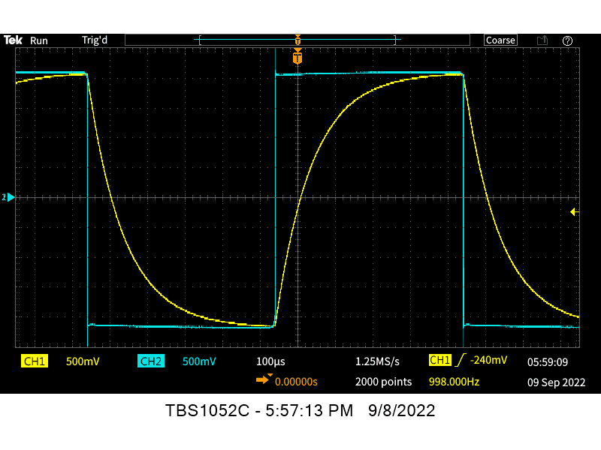
Figure 7. The figure above show the results from the 8 kHz pulse signal applied to the physical cirucit. The results closely match the anticipated results from the computer models as seen in Figure 3.

Phase shift and Voltage Transient response
The transient response of the physical circuit closely matches the results provided by the computer model. I believe the results are accurate to ±10%.

Figure 8. The figure above show the transient repsonse from the physical model

Method for testing for unknown Capacitor
Method 1: Using Equation 4, the value for a capacitor can be calculated with just a DMM. Using the DMM to measure the output voltage, one must only solve for the unknown value of the capacitor in the formula.
Method 2: Using Equations 1 and 2, the value of the capacitor can be calculated by measuring the time shift or the phase shift with the oscilloscope.
Method 3: Use DMM to measure capacitance directly.

Conclusion
LT-Spice is a reliable software package and seems to accurately characterize physical models. The results all matched quite well.

